Chapter 15, Problem 44.

Obtain the convolution of the pairs of signals in Fig. 15.38.

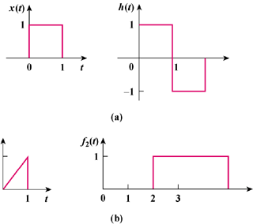

Figure 15.38
For Prob. 15.44.

